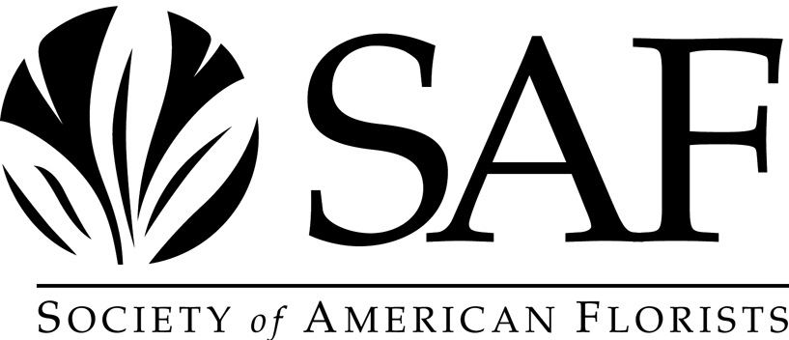

Dear Industry Member:

Thank you for your interest in nominating an individual to the Society of American Florists’ Floriculture Hall of Fame.

As the national trade association for the floral industry, SAF views the Hall of Fame as an opportunity to celebrate our industry’s heroes. Accordingly, the Awards Committee strives to identify individuals who exemplify either, or both of the following two characteristics:

- The person has been instrumental in creating significant and lasting improvements or innovations for the industry, or
- The person has performed such extraordinary service within the industry that he/she has become an inspiration throughout the floral community.

The deadline for nominations is April 1, 2025.
Please complete and return all five pages of the attached nomination form plus a black/white photo if available to: Lizzy Kubica, Awards Committee Liaison, Society of American Florists, 1001 N Fairfax Street, Suite 201, Alexandria, VA 22314, lkubica@safnow.org

Instructions:

Read instructions carefully before filling out nomination form.

- Please print legibly or type nomination form.

- Be as accurate and factual as possible. Wherever there is a question of accuracy (dates, for example), always qualify with “about” or “approximately” but use these only when necessary. DO NOT use alphabetical abbreviations.

- DO NOT duplicate. If you include information in one place, do not repeat it elsewhere.

- If extra space is needed, attach additional sheets identifying the number of the corresponding question to which the information relates.

- Recheck all items on the nomination form carefully before mailing. Make sure all items are accurately and completely filled in before returning.

- Attach a black/white photo of the nominee if available.

- DO NOT attach exhibits of any kind. The Awards Committee will write to you if further information of this type is required.
Special note: Please study the entire nomination form before you complete it out. Care in filling out the information required is of extreme importance. Incomplete or inaccurate recording of facts frequently causes undue delay and disappointment. Please keep in mind that the information requested is kept confidential. If you have any questions, please feel free to contact Lizzy Kubica at lkubica@safnow.org

Floriculture Hall of Fame

Deadline: May 1, 2025

Date:

1. Nominee’s Full Name:

2. Firm/Institution Name:

Address:

Phone/Fax Numbers:

E-mail:

3. Home Address:

Home Phone/Fax:

4. Date of Birth:

5. Total Number of Years in the Floral Industry:

SUBMITTED BY:

Firm:

Address:

E-mail Address:

Phone/Fax Numbers:
DIVISION I - Nature, value and permanency of contributions to the floral industry:

6. Contributions to the advancement and improvement of floriculture.

DIVISION II - Personal experience, competency and leadership in floral industry activities:

7. Participation and leadership in local, state and national floral associations:

8. Articles in floral publications:

9. Speaker at association meetings, when and where:

Event Date

DIVISION III - Character and Integrity:

10. Consideration of others, sense of fair play, etc. in business dealings, general business ethics:

11. General personal conduct in business and professional life and association activities:

DIVISION IV - Other factors including leadership in community and other activities:

12. Participation in local community affairs (service clubs, charitable organizations, church groups, etc.)

13. Other information not covered (give brief details):

14. Reflecting on all of the nominee’s contributions to the floral industry, which contributions stand out as having the most significant lasting impact on our industry? In other words, how has this nominee changed our industry in a positive way?

