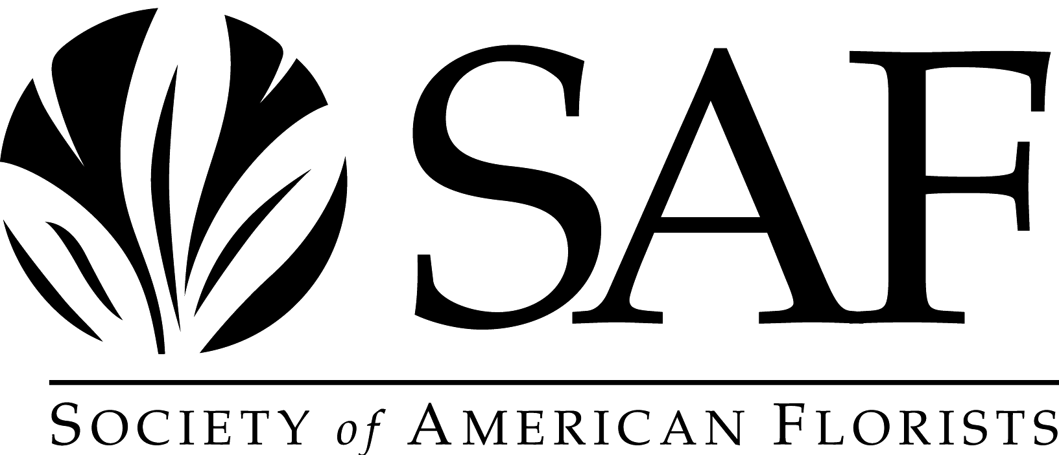

Gold Medal Award Nomination Form

The SAF Gold Medal Award is awarded by the Society to the originator or introducer of a widely distributed plant or flower that has become established as an outstanding product of significant horticultural and commercial value. This award may not be given for any plant or flower within five years of its dissemination.

Nominations stay active for a period of five years.

To nominate an individual to receive this award, please complete the nomination form and return it to:

Lizzy Kubica, Awards Committee Liaison
Society of American Florists
1001 N. Fairfax Street, Suite 201
Alexandria, VA 22314
lkubica@safnow.org

The deadline for receiving nominations is April 1, 2025

Society of American Florists
Gold Medal Award Nomination Form

Please type or print clearly.

Nomination For: ________________________________________________

Organization: ________________________________________________

Address: ________________________________________________

City/State/Zip: ________________________________________________

Phone/Fax: _____________________________________________

E-mail Address: _____________________________________________

Your Name: _____________________________________________

Organization: _____________________________________________

Address: _____________________________________________

City/State/Zip: ______________________________________________

Phone/Fax: _____________________________________________

E-mail Address: _____________________________________________

Are they a member of SAF: Yes No

Reasons they should receive the Society of American Florists Gold Medal Award -- please be as specific as possible and include plant/flower that has become established as an introduction of outstanding horticultural and commercial value (attach additional pages if necessary).

_________________________________________________________________________

_________________________________________________________________________

_________________________________________________________________________

_________________________________________________________________________

May we contact you for additional information if necessary? Yes No

DATE OF NOMINATION: ________________________________________________

