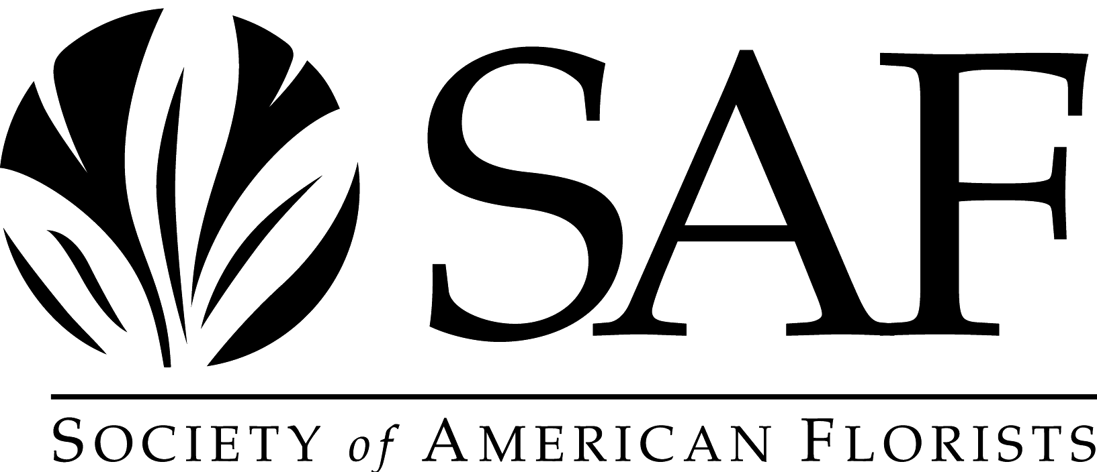

Century Award Application & Questionnaire

Any business or organization that has served the floral industry for 100 years or longer qualifies for the Century Award. The award was first presented in 1982.

The deadline for receiving this application and questionnaire is April 1, 2025.

Name of Company: ___________________________________________________

Address, Phone, Website & Email: ______________________________________

____________________________________________________________________

____________________________________________________________________

Submitted by: ______________________________________

Submitted by/Phone/Email: ____________________________________________

Date of Application: ______________________

Number of years in business: ______________

Date business first opened: _______________

***************************

Please list all owners and years of ownership if other than single owner:

____________________________________________________________________

____________________________________________________________________

____________________________________________________________________

____________________________________________________________________

____________________________________________________________________

____________________________________________________________________
Awards received from other groups for being in buiness for 100 years:

____________________________________________________________________

____________________________________________________________________

____________________________________________________________________

____________________________________________________________________

____________________________________________________________________

____________________________________________________________________

____________________________________________________________________

Please provide a brief history of your business (attached separate sheet if necessary):

____________________________________________________________________

____________________________________________________________________

____________________________________________________________________

____________________________________________________________________

____________________________________________________________________

____________________________________________________________________

____________________________________________________________________

____________________________________________________________________

____________________________________________________________________

____________________________________________________________________

Please complete the nomination form and return it to:

Lizzy Kubica, Awards Committee Liaison
Society of American Florists
1001 N. Fairfax Street, Suite 201
Alexandria, VA 22314
lkubica@safnow.org

