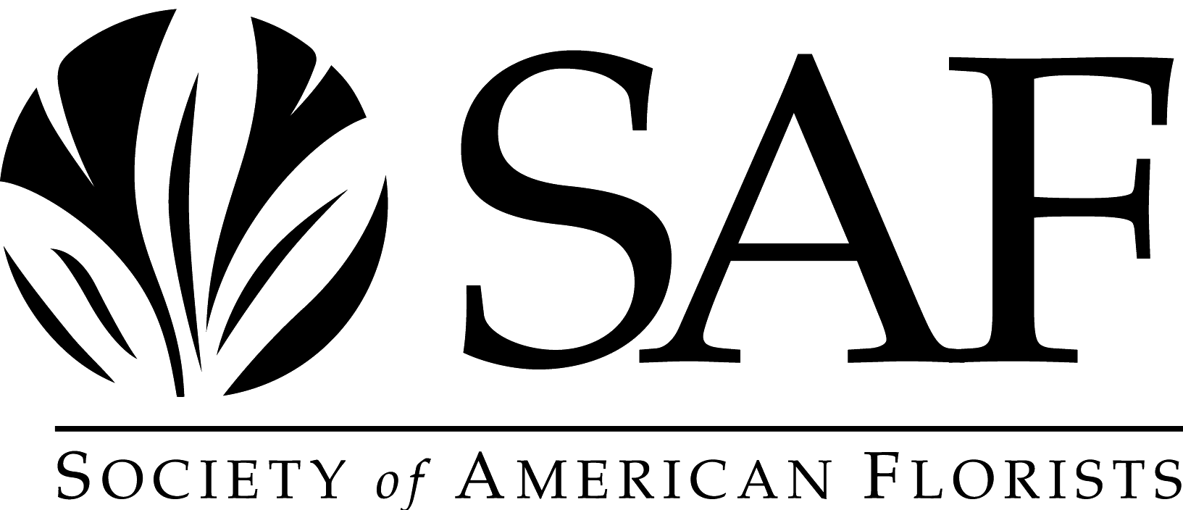

THE JOHN H. WALKER AWARD

PURPOSE: To recognize the growing importance of association executives in the workings of the Society of American Florists and to honor the contributions of SAF's long-time Executive Vice President, John H. Walker.

Award Criteria:

- Nominations must be endorsed by the president of the employing association(s).

- Recipient must be employed (i.e. paid staff) by a member association of SAF.

- Recipient must have a minimum of 3 years continuous service with a member association.

- The Awards Committee will specifically consider:

- Creative and substantial implementation of industry and SAF-sponsored programs beneficial to member associations (and their individual members) and our various other publics.

- Enrollment or attendance at professional schools, seminars, meetings, or courses which tend to contribute to an executive's ability to better serve member associations and their members.

- The nominee's service in leadership positions in professional societies and organizations dedicated to professionalism association management.

- The nominee's involvement in civic and community organizations.

- Evidence of a nominee's sharing his management skill and abilities with associations and association executives.

- The nominee's contributions and achievements to his or her association.

Please submit your completed application to:

Lizzy Kubica, Awards Committee Liaison
Society of American Florists
1001 N Fairfax Street, Suite 201
Alexandria, VA 22314
lkubica@safnow.org

Award Nominations Must be Submitted By May 1, 2025

THE JOHN H. WALKER AWARD

Instructions:

- This nomination form must be completed, endorsed, and received at SAF headquarters
by May 1, 2025.

- Pages may be added if necessary to elaborate on or complete information requested.

- Additional information supplied must be typed on standard 8½ X 11 inch paper.

- Please attach a suitable color glossy photograph of the nominee for promotion purposes.

Name:

Association:

Title:

Address:

City/State/Zip:

Phone:

Fax:

E-mail:

- Employment history with member associations of SAF (Give dates and titles).

- Give specific dates and titles of creative and substantial implementation of industry-sponsored and SAF-sponsored programs beneficial to member associations (and their individual members) and our various other publics.

- Give specific dates and courses of enrollment in professional (association management) schools, seminars, meetings and courses.

- List those leadership positions and dates of office held in professional societies and organizations dedicated to professionalism in association management.

- Give specific involvement in civic and community organizations.

- How has nominee shared his/her management skills and abilities with associations and association executives (be specific).

- Give specific contributions and achievements to employing association.

- Other comments

SUBMITTED BY: _______________________________________________________________

Signature of President of Employing Association Date

Association Name

