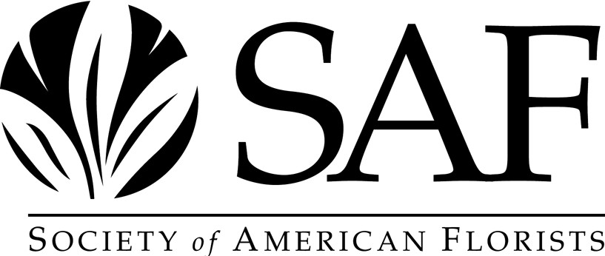

# Instructions for Filing an Application with the American Academy of Floriculture

PLEASE READ AND FOLLOW THESE INSTRUCTIONS CAREFULLY

Please fill out the application completely and accurately. Please keep in mind that all information will be kept confidential.

1. Please read the criteria and application for admission to the Academy in its entirety before you fill anything out.
2. Please type or print legibly.
3. ***There is a non-refundable application fee of $150***. **A credit card payment via phone (703-838 5230) or check in that amount must accompany this application.**
4. Please return the completed application with your credit card payment or a check made out to SAF

**by May 1, 2025** to: **Lizzy Kubica, Society of American Florists, 1001 N. Fairfax Street, Suite 201, Alexandria, VA 22314** or via email at [lkubica@safnow.org.](mailto:lkubica@safnow.org)

********************************************************************************

## CRITERIA FOR ELIGIBILITY FOR ADMISSION TO THE AMERICAN ACADEMY OF FLORICULTURE

**OF THE SOCIETY OF AMERICAN FLORISTS**

These criteria are the minimum criteria for applicants for admission to the American Academy of Floriculture. **Meeting the minimum criteria does not automatically confer membership in AAF or guarantees admission to AAF.**

## GENERAL CRITERIA

1. The candidate for admission must be a member in good standing of the Society of American Florists for three years or more and must maintain that membership to use the AAF designation.
2. If applicants are owners, principals or partners of a business, they must have a favorable credit rating as evidenced by three letters from trade references. If applicants are employees of a member firm, they must provide two letters of personal reference. Personal reference letters should be from employees from your company.
3. The candidate for admission must be endorsed in writing by two current members of the Academy. Endorsement letters should not be from immediate family members or same company employees. See the list of AAF members on the SAF website.
4. The candidate for admission must have served or worked in the floral industry on a full-time basis a minimum of five years.

## COMMUNITY SERVICE

Admittance to the American Academy of Floriculture is an honor that is bestowed on those who have not only contributed to their industry, but also to their community. As evidence of a candidate's community service, a candidate should meet three of the twelve criteria listed below.

1. The candidate for admission is a current or former active member of a community service organization such as the Kiwanis, Soroptimists, PTA, etc.
2. The candidate has been actively involved in a community service project.
3. The candidate has been actively involved in charities and/or religious leadership.
4. The candidate has served as chairman of a local civic service project.
5. The candidate has actively participated in a neighborhood or community improvement or beautification project.
6. The candidate has served as an officer of a neighborhood or community organization.
7. The candidate has served as an officer or director of a community service group or organization.
8. The candidate has been actively involved in a local issue or referendum such as a school bond or tax issue.
9. The candidate has served as an elected local or state official.
10. The candidate has served on a community board such as a planning board.
11. The candidate has been the recipient of an award for community service.
12. Other community service.

## INDUSTRY SUPPORT

1. The candidate for admission must hold membership in the local, state or regional allied floral organization serving his or her area, if available.
2. The candidate for admission must have served as a member of a committee or on the board of directors of a local, state, or regional allied floral organization, or the Society of American Florists or another major national floral association recognized by the Society of American Florists, such as WF&FSA, AIFD, wire services, etc.
3. In addition to the two requirements listed above, the candidate for admission must meet at least three of the following criteria:
   * The candidate has attended an educational program sponsored by SAF or a floriculture and horticulture organization recognized by SAF designed to improve the candidate’s competence in the floral business.
   * The candidate has attended a state, regional or national convention of a floricultural organization recognized by the Society of American Florists.
   * The candidate has conducted at least 60 minutes’ worth of educational programming (a seminar, class, series of classes or how-tos).
   * The candidate has written an article published in the official publication of SAF or one of its allied organizations.
   * The candidate has conducted a program of at least 30 minutes' duration on some aspect of floriculture or horticulture for members of the public, i.e., a program at a service club meeting.
   * The candidate has conducted a program informing students at the high school or college level of the benefits of a career in floriculture and horticulture.
   * The candidate has engaged in or supported scientific research designed to improve the quality or selection of floriculture and horticulture varieties.
   * The candidate has received an award from SAF, or another floriculture and horticulture organization recognized by SAF recognizing the candidate’s contribution.
   * The candidate has served as a volunteer designer or commentator at an industry gathering such as a convention or educational program.
   * The candidate has created extensive content showing expertise on flowers and plants on a social media outlet, YouTube channel or on TV creating a voice, new perspective, or new audience for floral products.
   * The candidate has acted as a spokesperson for promoting flowers, plants and/or design on a social media platform with at least 1,000 subscribers.

Candidates who meet the minimum criteria and who file an application by the **May 1, 2025, deadline** will be considered for admittance by the Awards Committee. All required documentation for the candidate needs to be completed and received by the deadline. Materials received after the deadline will be held for consideration the following year.

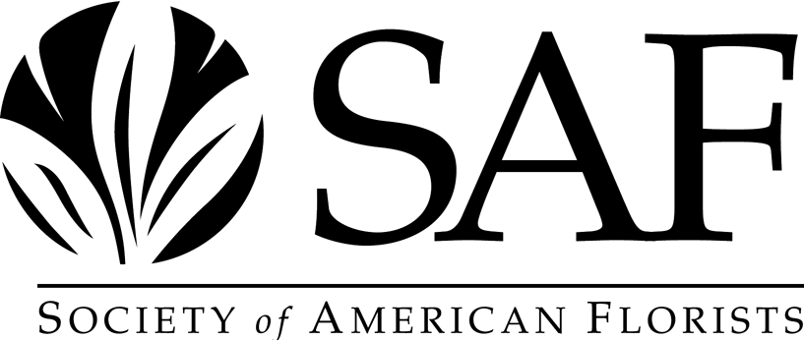

**AMERICAN ACADEMY OF FLORICULTURE APPLICATION FORM**

**Please type or print legibly.**

1. **Applicant's Full Name:**
2. **Business Address: (Firm)**

Street:

City State Zip

Primary Phone E-mail

Position or Title

1. **Home address: (street)**

City State Zip

1. **Total number of full-time years in the floral industry:**
2. **Positions of employment in the floral industry (excluding part time)**

From: To:

From: To:

From: To:

From: To:

From: To:

1. ***Owners***: Please enclose **three (3)** letters of credit reference from suppliers with whom you currently do business **AND two (2)** letters of endorsement from current members of the Academy. ***Non-owners***: Please enclose **two (2)** letters of personal reference **AND two (2)**

letters of endorsement from current members of the Academy. **These letters are required and are considered part of the minimum criteria you must meet for your application to be reviewed.**

1. **Educational Background:**

**Schools Attended Dates Degrees or Certificates**

1. **Other education or training, which aided in career (give details):**
2. **How do you stay up to date on new business practices and products available to the industry?**

# COMMUNITY SERVICE

**NOTE:** "Community Service" refers to roles of service outside the industry in organizations involved with the Arts, Politics, Religion, Philanthropy, Charitable Service or Business.

**Letters of recommendation from someone with whom you have worked on a community service project are welcome in addition to the required letters in item 7.**

1. **Community Activities**: (If the purpose or function of any organization listed is unclear or needs further explanation, please place an "X" in front of the organization in question and provide additional information on the back of this page or on a separate sheet.)

**Organization Position Held Dates of Service**

1. **Awards and/or honors received outside the floral industry:**

**Organization Award Date Reason**

1. **If you wish to include any additional information on your community activities, please elaborate:**

**INDUSTRY ACTIVITIES**

1. **List any floral industry organizations of which you (or your company) are a member: Organization Dates of Membership**
2. **List positions of leadership in floral associations:**

**Organization Positions Held Dates of Service**

1. **List programs in which you have been involved that were of benefit to the industry: Project/Event Position of Responsibility Dates**
2. **List speeches to industry groups that you have given:**

**Organization Addressed Subject Date**

1. **List any articles you have written that have been published in the industry press.**

**Publication Subject/Title Date**

1. **List any shows or workshops in which you have been a panelist, designer or otherwise participated:**

**Sponsoring Organization Your Role Date**

1. **List any awards or honors received within the floral industry: Organization Award Date**

1. **Use this space to explain in detail if you have created extensive content showing your expertise on flowers and plants in a newspaper or other publication, on TV or via a social media outlet, YouTube channel, or if you act as spokesperson for promoting flowers, plants and/or design on a social media platform with at least 1,000 subscribers:**
2. **Please list here any additional information that you would like to bring to the attention of the Academy relative to your candidacy for admission.**



**APPLICATION DEADLINE: May 1, 2025**

**Society of American Florists**

**Lizzy Kubica, Awards Committee Liaison 1001 N. Fairfax Street, Suite 201 Alexandria, VA 22314**

**703-838-5230**

[**lkubica@safnow.org**](mailto:lkubica@safnow.org)