Business of Design Recipes, January 2018

Blush Elegance
White dimple pot
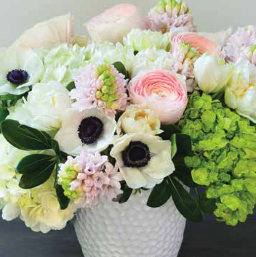
3 mini green hydrangeas
2 white hydrangeas
5 pink hyacinths
4 blush ranunculus
3 white anemones
5 white tulips

Strawberry Fields
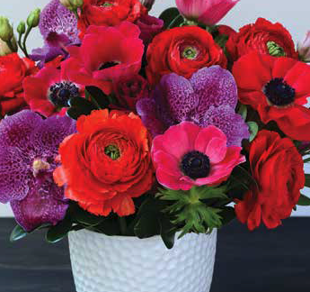
White dimple pot
3 fuchsia vanda orchids
7 red ranunculus
5 fuchsia anemones
4 red anemones
3 stems red lisianthus

