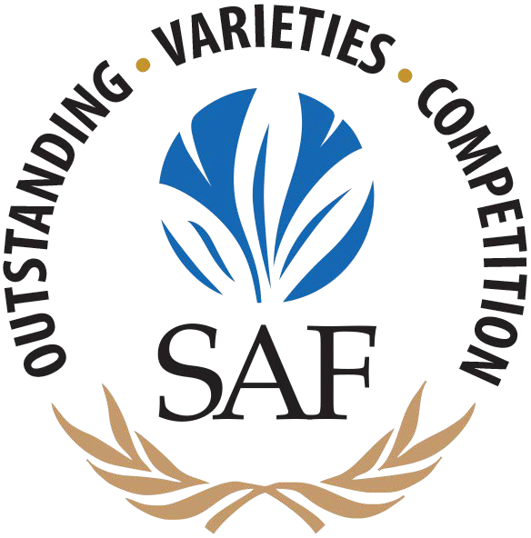**2025 Outstanding Varieties Competition Rules and Regulations**

Please read the following carefully. SAF reserves the right to exclude any entry from the competition that does not meet all conditions as specified below.

# WHEN: WHERE: INFORMATION:

August 11-14 at the 140th Annual SAF Convention

The Westin Kierland Resort & Spa, Scottsdale, Arizona

Contact Laura Weaver at 703-838-5221; [lweaver@safnow.org](mailto:lweaver@safnow.org)

# Entries must be received by Monday, July 14 with full payment. No entries will be accepted past this date, no exceptions.

* There are two ways to enter the 2025 Outstanding Varieties Competition:
  + Growers can enter varieties that are currently available on the commercial market.
  + Breeders can enter varieties that have not yet been introduced (known as “codes”).
* Grower entries are separated into categories by plant or flower type (ex. Cut Rose, Cut Alstroemeria, Decorative Foliage, etc). Breeder entries will all be judged in their own Breeder category, regardless of the type of plant or flower. No Breeder entries may be judged in any of the grower categories or vice versa. **SAF reserves the right to remove or disqualify, without refund, entries that attempt to be judged in an incorrect category.**
* Chrysal Americas is the official sponsor of the 2025 Outstanding Varieties Competition. Chrysal Americas hydrating and preservative products are available for use by exhibitors during the duration of the competition. ***The Chrysal Americas products supplied are the only products of this kind that can be used during the competition.***
* It is recommended that exhibitors prepare and set up their own entries. Company representatives responsible for setting up entries are required to check-in with the Outstanding Varieties coordinators upon arrival at the hotel to receive instructions.
* Printed materials of any kind supplied by exhibitors are prohibited during the competition. This includes but is not limited to promotional materials, props or special signage. Only SAF approved and designated materials may be displayed.
* Decorative materials or other non-perishable supplies of any kind used in floral design are prohibited during the competition. This includes but is not limited to paints, sprays, foam, wire, ribbon, dyes, tints or other simi- lar supplies.
* Entries that have been dyed or tinted in any way will not be permitted to enter the competition.
* Knives and cutting tools generally found in any floral industry business may be used during set-up of the competition. Mechanical devices or tools of any kind are prohibited during the competition.
* Fresh flower and decorative foliage entries will consist of no more than 24 stems of the variety. SAF reserves the right to admit and display the entry if less than the maximum number of stems (24) are available.
* Flowering, foliage and bedding plants must be displayed in non-decorative packs or pots. Three samples of the variety must be provided, and samples may be of mixed form at the discretion of the exhibitor. SAF re- serves the right to admit entries if less that the required number of sample (3) are available.
* SAF will provide adequate workspace, knives, access to water, floral preservatives and standard containers for preparing and displaying fresh flowers and foliage.
* SAF will maintain the product during the duration of the competition according to currently accepted proce- dures for proper care and handling of floral products.
* SAF reserves the right to withdraw from the competition any product deemed unacceptable for display. No refunds will be made for product that is determined to be unacceptable.
* SAF reserves the right to not issue Best in Class Ribbons when there are less than 3 entries in a class.
* SAF and the Outstanding Varieties Coordinators have the final authority to resolve disputes in a way they feel supports and honors the integrity of SAF, the Outstanding Varieties Competition and individual exhibitors.

**2 2025 Outstanding Varieties Competition Procedures**

* There is ***NO LIMIT*** to the number of varieties that can be entered in the competition.
* Preparation for the competition will take place on Saturday, August 9 from 11 a.m. – 5 p.m., Sunday, August 10 from 8 a.m. to 5 p.m.; and Monday, August 11 from 8 a.m. to 10 a.m. All entries must be completely set up by 10 a.m. on Monday, August 11. ***There are no exceptions to this rule.***
* SAF will decide on the final placement of entries in the competition.
* Any entry not set up by an exhibiting company by 10 a.m. on Monday, August 11 will be set up by SAF. The exhibiting company will be charged an onsite set-up fee of $125 for each entry SAF must set up.
* All entries set up by SAF will be done by a floral professional.
* Products entered into the competition will be delivered to the hotel on the morning of Saturday, August 9

in a refrigerated truck where they will be stored until set up begins.

* Delivery method and delivery expenses for shipping products are the responsibility of the exhibiting company.
* Upon receipt of entry forms and payment, exhibitors will receive neon green labels that should be placed on the outside of the shipping boxes. These labels will help SAF quickly identify product for the competition versus product being donated for the SAF Phoenix 2025 convention. ***Please be sure to display these***

***neon green labels on the outside of your boxes.***

* Entry fees are payable with submission of the entry forms to SAF. Fees for entries canceled on or before

July 7, will be refunded less a 15% administrative charge***. No refunds will be made after July 14.***

* Substitutions for paid entries will be accepted until July 14. ***Absolutely no substitutions will be accepted after July 14 or on site in Phoenix.***
* Refunds or credits will not be issued for damaged product, product not exhibited or product that does not arrive before set up deadline.